

**School of Computing, Engineering and Physical Sciences**

**MSc Information Technology**

**COMP11113 Information Systems Analysis and Design**

**GROUP COURSEWORK 2 (60% of the marks)**

**Session 2024/2025 Term 1**

**Students**

1. Prajwalaradhya Shivakumaraswamy Kesaramadu (B01759301)
2. Aman Misra (B01746656)
3. Sreeraj Karuvanthodi Ramachandran (B01764963)
4. Muhammed Ali Panthalingal (B01755979)

Lecturer: Raja Ujjan, Ashraf Mahmud

Submission Date: 19-12-2024

**Declaration**

I have carefully read and fully understand Regulations 3.49–3.55 of Chapter 3 of the Regulatory Framework of the University of the West of Scotland, which outline the rules and policies regarding cheating and plagiarism.

I confirm that this assessment is the collective work of our group, with each member contributing to the completion of this task. Where applicable, we have clearly referenced and acknowledged the contributions or ideas of others outside our group.

I also affirm that no part of this assessment has been written, in whole or in part, by anyone outside the group, except for explicitly referenced sources.

Furthermore, I confirm that this assessment has not been submitted previously, either partially or fully, for any other module or academic purpose, ensuring it does not fall under self-plagiarism.

This declaration is made with honesty and integrity in adherence to the University’s academic standards.

Table of Contents

1. Use Case Diagram 4

2. Structured English 5

3. Class Diagram 6

4. Sequence Diagram 7

Group Meeting Form 8

# 1. Use Case Diagram

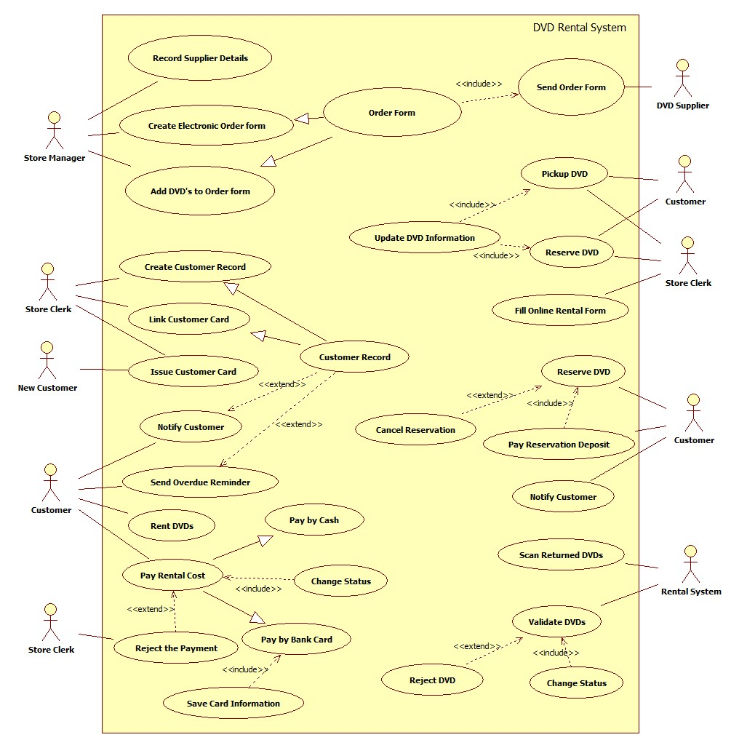

# 2. Structured English

Customer picks up DVDs

Clerk gets customer card to scan in the machine

If (the system accepts the card) (**special case**)

Clerk clicks the RENTAL button

Fills Online Form for the Customer

End if

Repeat

system validates barcode stored in the system

if (barcode does not match)

system reject the DVD

else

System will add a new rental line in new form with details

rental price is added to total rental cost

until (All DVDs are scanned)

Customer pay the Total Money by Cash or Card

If (card is used for the 1st time) (**special case**)

Clerk save the details of Customer and Card in System

End if

Clerk process the Payment manually

If (payment is invalid) (special case)

Clerk rejects the Payment & Clicks Cancel button (**error case**)

Else

Clerk clicks COMPLETE button to Save in the System

End if

Status changes for all DVDs from "**in**" to "**out**" in the system

Show Success Message

Clerk Enters Staff number in the system

System links Clerk record to Rental form

# 3. Class Diagram

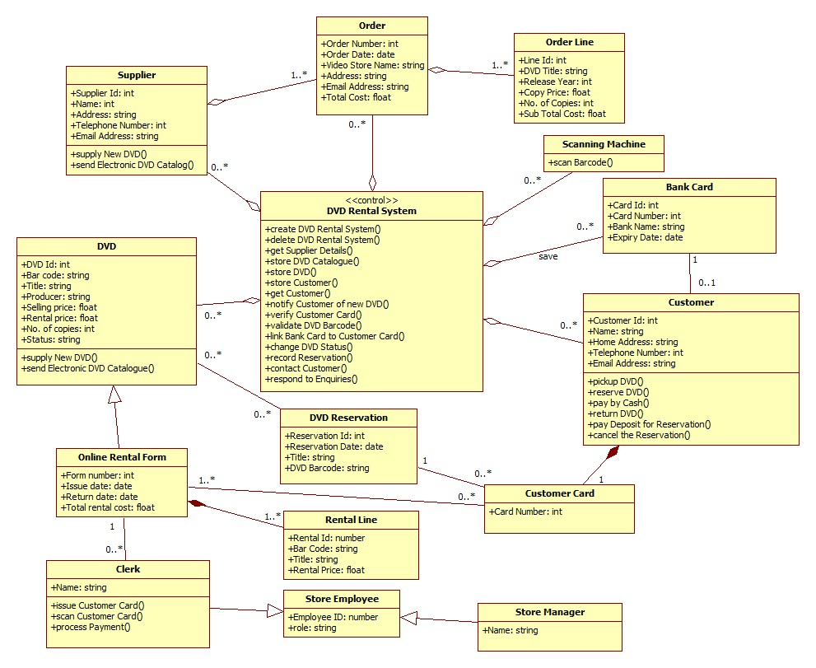

# 4. Sequence Diagram

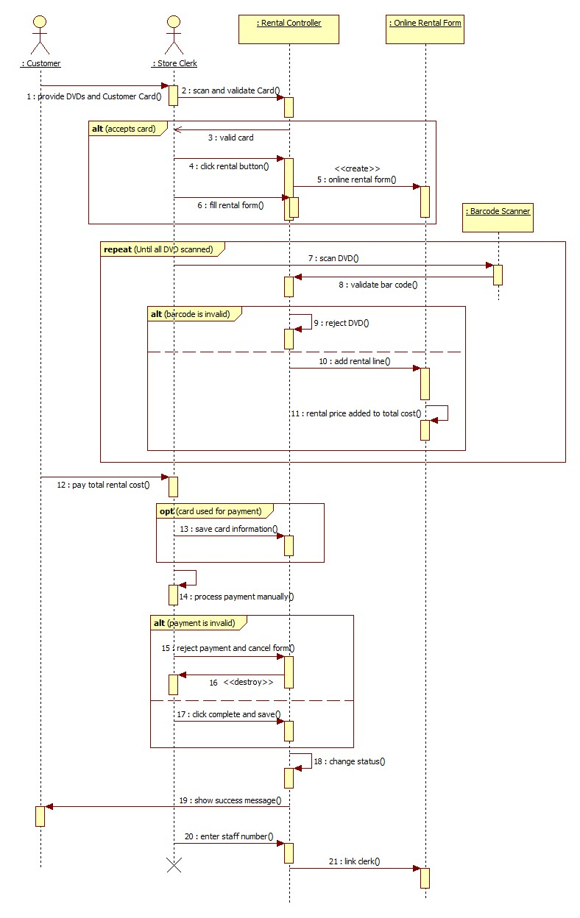

# Group Meeting Form

|  |  |
| --- | --- |
| **Group Meeting Number**: 1 | **Meeting Date/Time**: 01-12-2024 |
| **Attendees Full Name/Banner ID**: B01759301, B01746656, B01764963, B01755979 | |
| **Progress**   * Complete tasks  1. Discussed about the case study and outlined important keywords. 2. Assigned tasks to group members. | |
| **Tasks To Be Completed by Next Meeting (Date/Time)**     1. Make a list of all the use-case actions, actors and possible connections. 2. List out the entities for the class diagram. | |

|  |  |
| --- | --- |
| **Group Meeting Number**: 2 | **Meeting Date/Time**: 04-12-2024 |
| **Attendees Full Name/Banner ID**: B01759301, B01746656, B01764963, B01755979 | |
| **Progress**   * Complete tasks over the last week  1. Listed all the actions and actors for use-case diagram. 2. Listed out all the entities for the class diagram.  * Incomplete tasks over the last week  1. Did not listed connections.   Reason: All members needed to understand the concept clearly. | |
| **Tasks To Be Completed by Next Meeting (Date/Time)**   1. List all the connections and create a use-case diagram. 2. Draw the class diagram using the entities listed with relationship between them. 3. Understand the use-case description and try to create a draft version. | |
| **Addition Note**: After making use-case description, understand the concepts of sequence diagram. | |

|  |  |
| --- | --- |
| **Group Meeting Number**: 3 | **Meeting Date/Time**: 08-12-2024 |
| **Attendees Full Name/Banner ID**: B01759301, B01746656, B01764963, B01755979 | |
| **Progress**   * Complete tasks over the last week   1. Completed the draft version of the use-case diagram.  2. Completed the class diagram with relationship.  3. Started the use-case description and sequence diagram. | |
| **Tasks To Be Completed by Next Meeting (Date/Time)**  1. Complete the Use-case description.  2. Complete the Sequence diagram. | |
| **Addition Note**: Recheck the use-case & class diagrams if anything is missing. | |

|  |  |
| --- | --- |
| **Group Meeting Number**: 4 | **Meeting Date/Time**: 11-12-2024 |
| **Attendees Full Name/Banner ID**: B01759301, B01746656, B01764963, B01755979 | |
| **Progress**   * Complete tasks over the last week   1. Completed the Use-case description.  2. Completed the Sequence diagram.  3. Aligned the diagrams to look professional and clearly.  4. Created a Word file and added all diagrams. | |